**Write Up**

Ken Oung Yong Quan | A0139388M

**Site Structure**

src/

| index.php // Landing Page

+ config

| config.php // configuration file

| global.php // global variables

+ model

| user.php // user related functions

| blog.php // blog related functions

| db.php // interactions with the database

+ helpers

| utils.php // utility helper functions

+ view

+ common

| header.php // standard header

| footer.php // standard footer

| home.php // view posts

| login.php

| edit_post.php

| delete_post.php

| add_post.php

+ static

+ img // images

+ css // css files

+ js // JavaScript files

**Database Schema**

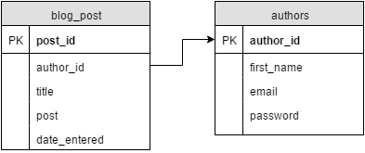

**Execution Plan**

* Have a nice landing page with an ‘enter’ button
* Leads to homepage with most recent blog posts
* Log in option from footer
* Log in gives access to admin controls for each post
  + Editing
  + Deleting
* Can also add a new post

**Notes**

* User authentication using cookies (consider using session?)
* Only blog_post side implemented, haven’t added support for new authors
* Current authentication only accepts the following:
  + Email: [admin@myblog.com](mailto:admin@myblog.com)
  + Password: password